Chapter 14, Solution 95.

- 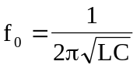

When 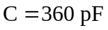,
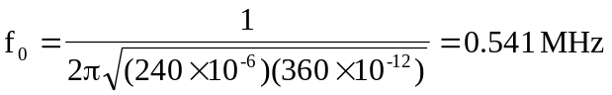

When 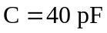,
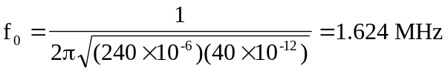

Therefore, the frequency range is
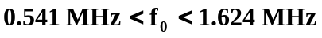

- 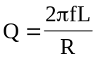

At 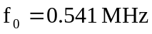,
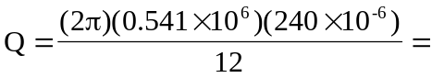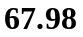

At 
